User

Manual

Payment Module

**Version 6.1**

|  |  |
| --- | --- |
| ***Corporate Office*** | ***Offshore Development Center*** |
| *1 Pickering Street*  *#06-03 Great Eastern Centre*  *Singapore 048659* | *Plot # 122 & 123, N.S.E.Z, Phase -2*  *NOIDA, UP 201 305*  *India*  *Tel: 91.11.91.2510483* |

|  |  |  |  |  |
| --- | --- | --- | --- | --- |
| **Author** | | | | |
| **Name** | **Role** | **Date of Preparation** | **Signature** | |
| Varun Gupta | Business Analyst | 30-Jan-2015 | Varun | |
| **Reviewer(s)** | | | | |
| **Name** | **Role** | **Date of Review** | **Signature** | |
| Pravesh Kumar | Manager Projects |  |  | |
|  |  |  |  | |
| **Approver** | | | | |
| **Name** | **Role** | **Date of Approval** | **Signature** | |
| ChengChoon Yip | VP Ebix Exchange  Asia |  |  | |
| **Document Path** | **Version Number** | **Date of Release** | | |
|  | 2.4 | 5 March 2015 | | |
|  | 4.0 | 31st March 2015 | | |
|  | 5.0 | 1 April 2015 | | |
|  | 5.1 | 15 April 2015 | | |
|  | 5.2 | 11 May 2015 | | |
|  | 6.0 | 30 June 2015 | | |
| **Revision History** | | | | |
| **Version Number** | **Date of Release** | **Section/ Page # Changed** | | **Details of Changes** |
| 1.0 | 5 March 2015 | Created document for system admin module | | Whole document Created |
| 4.0 | 31st March 2015 | 23 / 115 | | Added upload module |
| 5.0 | 1 April 2015 | Whole document | | Changed sequence of Menus as per actual system admin master sequence. |
| 5.1 | 15 April 2015 | 5.1.4 Select Permission List Screen | | Updated as per latest requirement of security management |
| 5.2 | 11 May 2015 | Section 12, 13 and 28 | | FAL, Common master manual and LOG Request module’s user manual added |
| 6.0 | 30 June 2015 | Payment section added | | Removed all modules and added Claim Payment module |
| 6.1 | 7 July 2015 | Entire document | | Edited sentences throughout the document. |

|  |  |  |
| --- | --- | --- |
| **References** | | |
| **Document** | **Date Received** | **Author** |
|  |  |  |

Contents

1 Claim payment processing 4

1.1 Payment Grid Screen 5

1.2 Payment Screen Section details 6

1.3 Payment Screen field’s information 8

‘

# Claim Payment Processing

* Once any mandate request has been approved for any claimant then the claim will appear in the Claim Payment Processing search screen.
* User can click on select button to make payment request.
* User will be able to submit Payment Requests that meet the following conditions:
  + Mandate approved amount must be greater than requested Payment amount.
  + Logged-in user must have Financial Authority Limit.

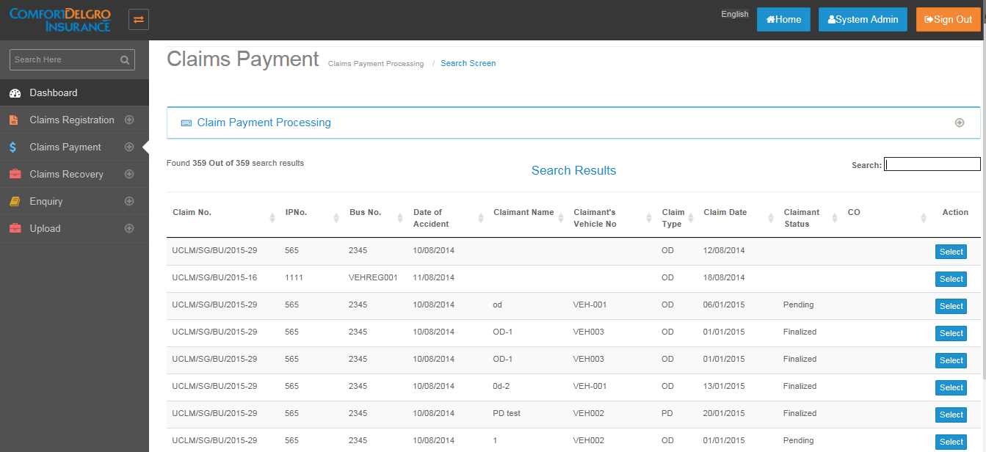

## Payment Grid Screen

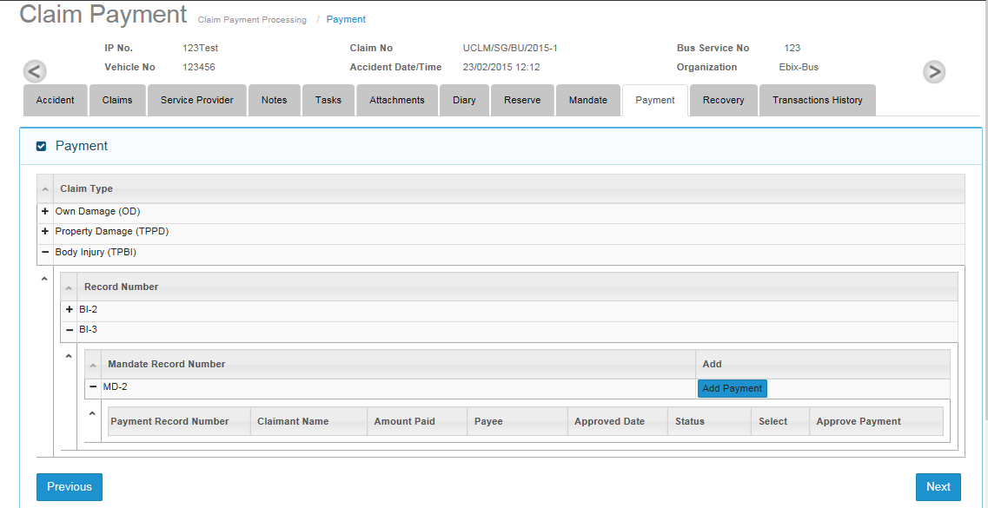

* User can navigate the payment grid by expanding Claim Type then Record Number then Mandate Record Number.
* Upon clicking on the Add Payment button, user will be able to create a Payment Request.

## Payment Screen Section details

* Payment Details
  + User will provide below mentioned details
    - Assigned To : Supervisor name
    - Payment Request Date
    - Payment Due Date
    - Payee: Service Provider or Claimant name
    - Payee Addresses
* Supervisor Approval
  + User will provide below mentioned details
    - Assigned To: This will automatically show CO Name.
    - Approve Payment : Radio button , user will choose Yes/No
    - Supervisor Remarks
* Claim Breakdown
  + This section has two columns. First column is “Amount Due” and second column is “Amount Mandate”.
  + In Amount Due column user can enter payment amount requested or overwrite existing requested payment amount
  + Amount mandate column will show non editable values from mandate approval column of mandate screen for that particular claimant.
  + User is unable to edit any approved payment requests.
  + After payment request has been approved, the corresponding amount will be deducted from reserve and mandate amounts of the selected claimant.

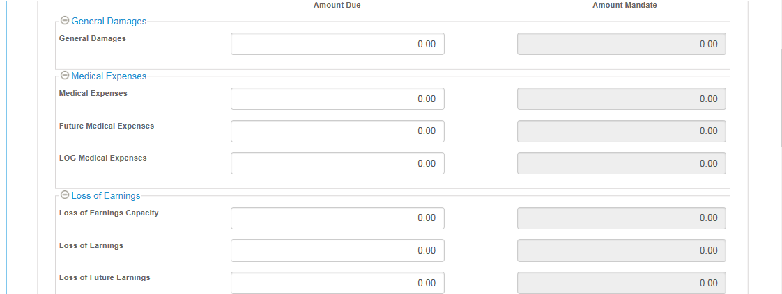

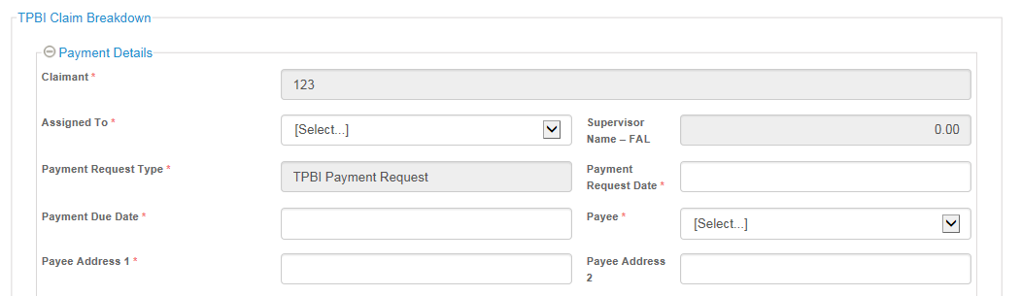 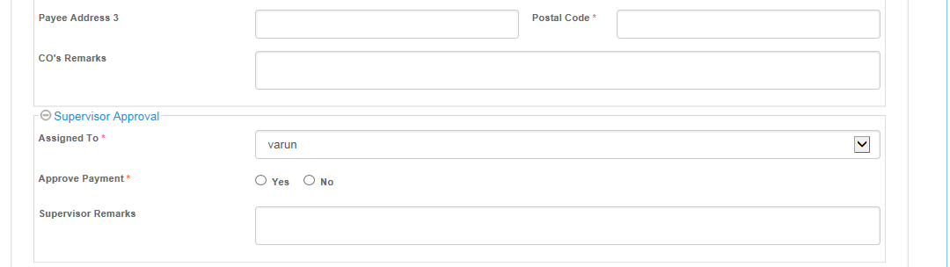 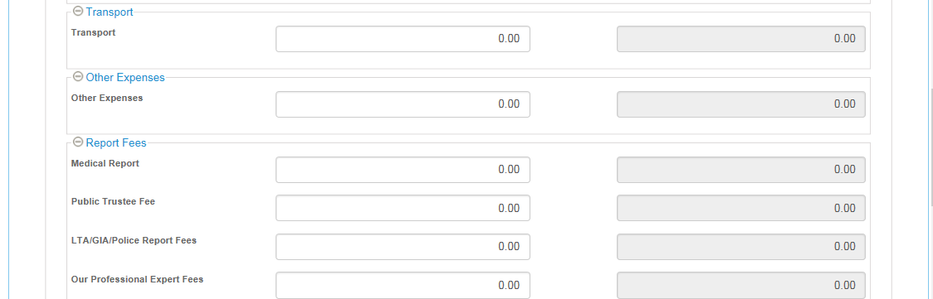

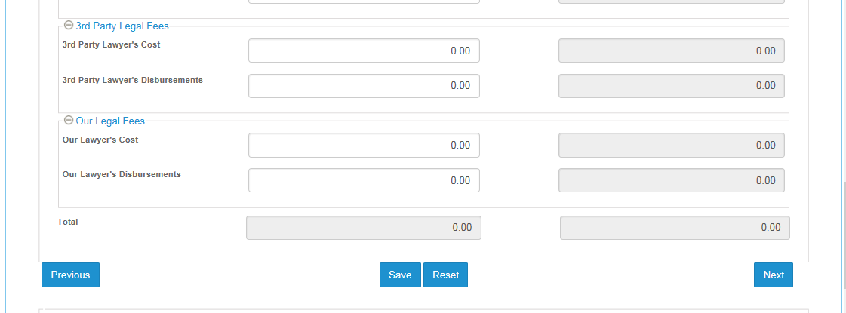 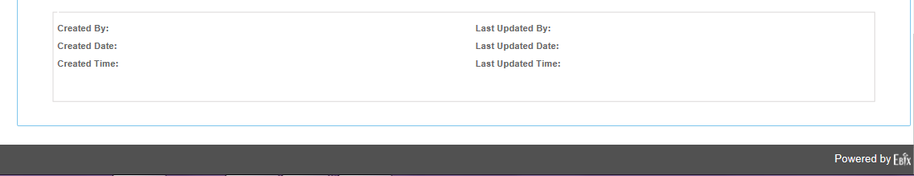

## Payment Screen field’s information

|  |  |  |  |  |
| --- | --- | --- | --- | --- |
| **Payment** | **Type** | **Field Type** | **Input Type** | **Input Selection** |
|  |  | Text / drop down/  radio button / check box | Text /Alphanumeric / number | Free text/ Dd-mm-yyyy /  Or values of drop down list |
|  |  |  |  |  |
| **TPPD Payment Request** |  |  |  |  |
| Claimant | Editable | Drop down | Alphanumeric | Data from list of Claimants created for this claim record |
| Assigned To | Editable | Drop down | Alphanumeric | Data from list of Supervisor (User Admin Master Table) |
| Payment Request Type | Populated | Drop down | Alphanumeric | TPPD payment Request TPBI Payment Request OD Payment Request |
| Payment Request Date | Editable | Text | Date | DD/MM/YYYY |
| Payment Due Date | Editable | Text | Date | DD/MM/YYYY |
| Payee | Populated | Drop down | Alphanumeric | Data from list of service providers created for this claim record |
| Address 1 | Populated | Text | Alphanumeric | Data from selected Service Provider in Payee field |
| Address 2 | Populated | Text | Alphanumeric | Data from selected Service Provider in Payee field |
| Address 3 | Populated | Text | Alphanumeric | Data from selected Service Provider in Payee field |
| Postal Code | Populated | Text | Numeric | Data from selected Service Provider in Payee field |
| CO's Remarks | Editable | Text | Alphanumeric | Free text |
| Cost of Repairs | Editable | Text | Numeric | 999,999,999.99 |
| Loss of Use | Editable | Text | Numeric | 999,999,999.99 |
| Loss of Earning | Editable | Text | Numeric | 999,999,999.99 |
| Loss of Rental | Editable | Text | Numeric | 999,999,999.99 |
| Excess | Editable | Text | Numeric | 999,999,999.99 |
| Other Expenses | Editable | Text | Numeric | 999,999,999.99 |
| Survey Fee | Editable | Text | Numeric | 999,999,999.99 |
| Re-Survey Fee | Editable | Text | Numeric | 999,999,999.99 |
| LTA/GIA/Police Report Fees | Editable | Text | Numeric | 999,999,999.99 |
| 3rd Party Lawyer's Cost | Editable | Text | Numeric | 999,999,999.99 |
| 3rd Party Lawyer's Disbursements | Editable | Text | Numeric | 999,999,999.99 |
| Our Lawyer's Cost | Editable | Text | Numeric | 999,999,999.99 |
| Our Lawyer's Disbursements | Editable | Text | Numeric | 999,999,999.99 |
| Total | Auto Calculated | Text | Numeric | 999,999,999.99 |
|  |  |  |  |  |
| **TPBI Payment Request** |  |  |  |  |
| Claimant | Editable | Drop down | Alphanumeric | Data from list of Claimants created for this claim record |
| Assigned To | Editable | Drop down | Alphanumeric | Data from list of Supervisor (User Admin Master Table) |
| Payment Request Type | Populated | Drop down | Alphanumeric | TPPD payment Request TPBI Payment Request OD Payment Request |
| Payment Request Date | Editable | Text | Date | DD/MM/YYYY |
| Payment Due Date | Editable | Text | Date | DD/MM/YYYY |
| Payee | Populated | Drop down | Alphanumeric | Data from list of service providers created for this claim record |
| Address 1 | Populated | Text | Alphanumeric | Data from selected Service Provider in Payee field |
| Address 2 | Populated | Text | Alphanumeric | Data from selected Service Provider in Payee field |
| Address 3 | Populated | Text | Alphanumeric | Data from selected Service Provider in Payee field |
| Postal Code | Populated | Text | Numeric | Data from selected Service Provider in Payee field |
| CO's Remarks | Editable | Text | Alphanumeric | Free text |
| General Damages | Editable | Text | Numeric | 999,999,999.99 |
| Medical Expenses | Editable | Text | Numeric | 999,999,999.99 |
| Future Medical Expenses | Editable | Text | Numeric | 999,999,999.99 |
| LOG Medical Expenses | Editable | Text | Numeric | 999,999,999.99 |
| Loss of Earning Capacity | Editable | Text | Numeric | 999,999,999.99 |
| Loss of Earnings | Editable | Text | Numeric | 999,999,999.99 |
| Loss of Future Earnings | Editable | Text | Numeric | 999,999,999.99 |
| Transport | Editable | Text | Numeric | 999,999,999.99 |
| Other Expenses | Editable | Text | Numeric | 999,999,999.99 |
| Medical Report | Editable | Text | Numeric | 999,999,999.99 |
| Public Trustee Fee | Editable | Text | Numeric | 999,999,999.99 |
| LTA/GIA/Police Report Fees | Editable | Text | Numeric | 999,999,999.99 |
| Our Professional Expert Fees | Editable | Text | Numeric | 999,999,999.99 |
| 3rd Party Lawyer's Cost | Editable | Text | Numeric | 999,999,999.99 |
| 3rd Party Lawyer's Disbursements | Editable | Text | Numeric | 999,999,999.99 |
| Our Lawyer's Cost | Editable | Text | Numeric | 999,999,999.99 |
| Our Lawyer's Disbursements | Editable | Text | Numeric | 999,999,999.99 |
| Total | Auto Calculated | Text | Numeric | 999,999,999.99 |
|  |  |  |  |  |
| **OD Payment Request** |  |  |  |  |
| Claimant | Editable | Drop down | Alphanumeric | Data from list of Claimants created for this claim record |
| Assigned To | Editable | Drop down | Alphanumeric | Data from list of Supervisor (User Admin Master Table) |
| Payment Request Type | Populated | Drop down | Alphanumeric | TPPD payment Request TPBI Payment Request OD Payment Request |
| Payment Request Date | Editable | Text | Date | DD/MM/YYYY |
| Payment Due Date | Editable | Text | Date | DD/MM/YYYY |
| Payee | Populated | Drop down | Alphanumeric | Data from list of service providers created for this claim record |
| Address 1 | Populated | Text | Alphanumeric | Data from selected Service Provider in Payee field |
| Address 2 | Populated | Text | Alphanumeric | Data from selected Service Provider in Payee field |
| Address 3 | Populated | Text | Alphanumeric | Data from selected Service Provider in Payee field |
| Postal Code | Populated | Text | Numeric | Data from selected Service Provider in Payee field |
| CO's Remarks | Editable | Text | Alphanumeric | Free text |
| Cost of Repairs | Editable | Text | Numeric | 999,999,999.99 |
| Loss of Use | Editable | Text | Numeric | 999,999,999.99 |
| Other Expenses | Editable | Text | Numeric | 999,999,999.99 |
| Survey Fee | Editable | Text | Numeric | 999,999,999.99 |
| Re-Survey Fee | Editable | Text | Numeric | 999,999,999.99 |
| LTA/GIA/Police Report Fees | Editable | Text | Numeric | 999,999,999.99 |
| 3rd Party Lawyer's Cost | Editable | Text | Numeric | 999,999,999.99 |
| 3rd Party Lawyer's Disbursements | Editable | Text | Numeric | 999,999,999.99 |
| Our Lawyer's Cost | Editable | Text | Numeric | 999,999,999.99 |
| Our Lawyer's Disbursements | Editable | Text | Numeric | 999,999,999.99 |
| Total | Auto Calculated | Text | Numeric | 999,999,999.99 |